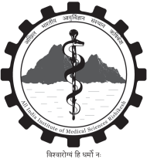
NO DUES CERTIFICATE
Date: __________

This is to certify that __________________________________ student of MBBS 2nd prof. ___________ has cleared all the dues of the following departments.
Sr. No. | Department | Seal & Signature of HOD/ Incharge
01. | Pathology
02. | Pharmacology
03. | Microbiology
04. | FMT
05. | Mess
06. | Accounts
07. | Library
08. | Hostel

